Download Git according to your system from here:

[Git Download Link](https://git-scm.com/download/)

Install the Git with default options selected.

Select Launch Git Bash.

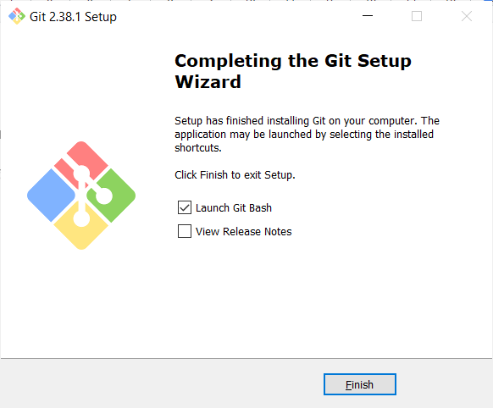

Then opens the GitBash interface in this way:

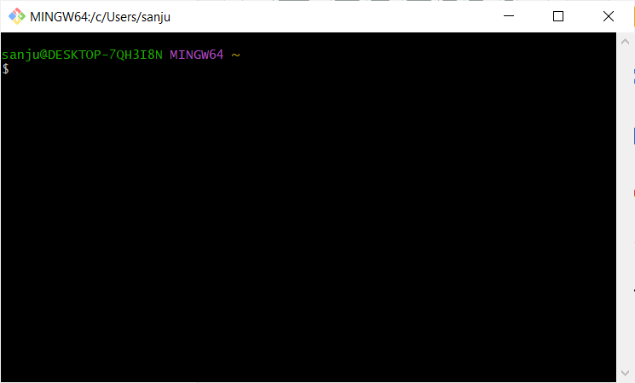

1. Lets check the version of Gitbash using following command:

**$git –version**

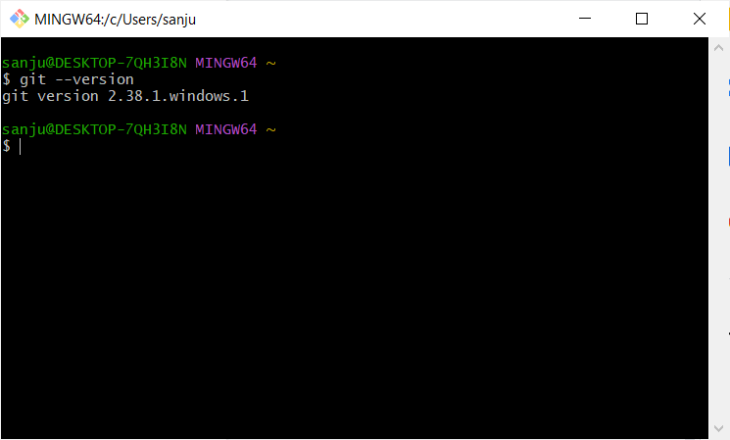

1. To help regarding commands in git:

**$git config –help**

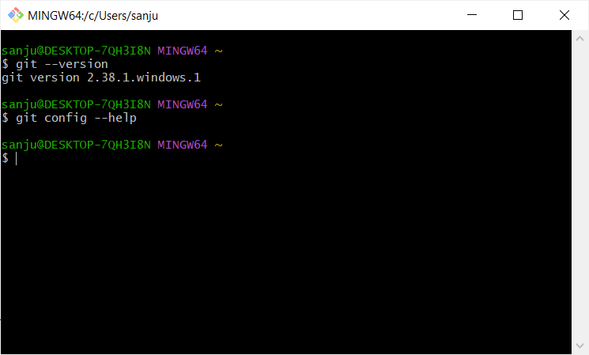

This file opens up where you can look for help regarding many commands.

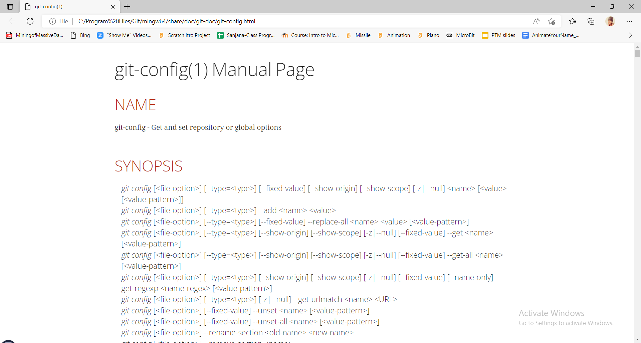

1. Creating local directory/folder on your system

**$mkdir foldername**

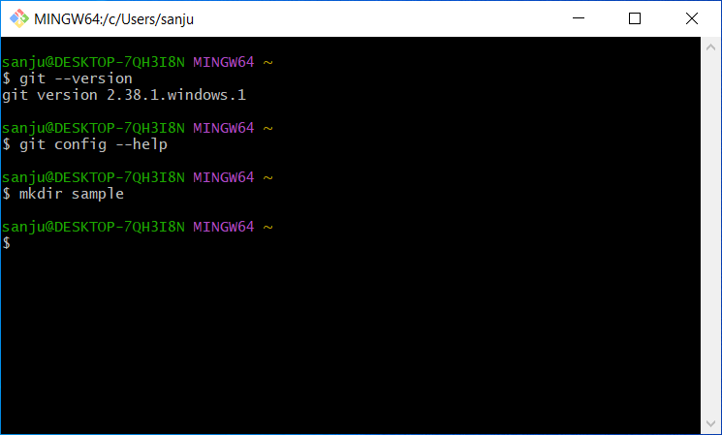

Changing the location to get inside the directory we created:

**$cd sample**

Initialising the directory:

**$git init**

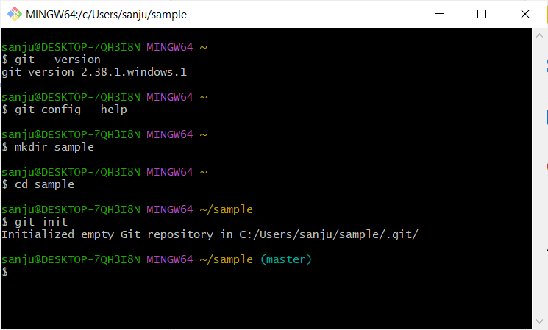

**Check in the path provided above through the Folder/Files. You should be able to see the folder created.**

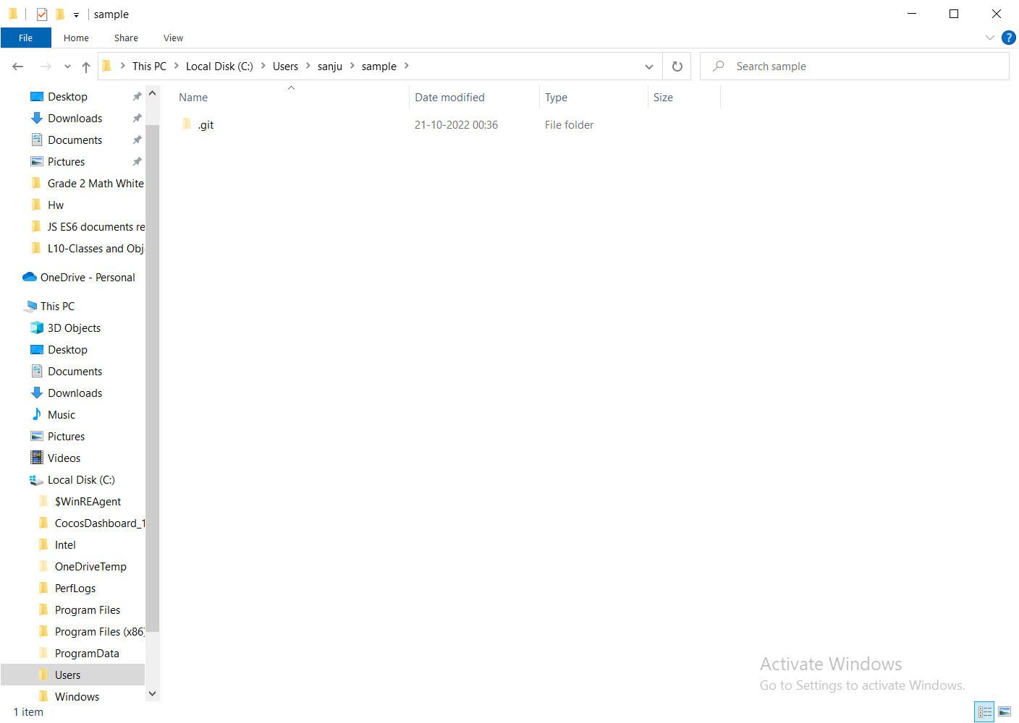

Make a text file named “Demo” with some content

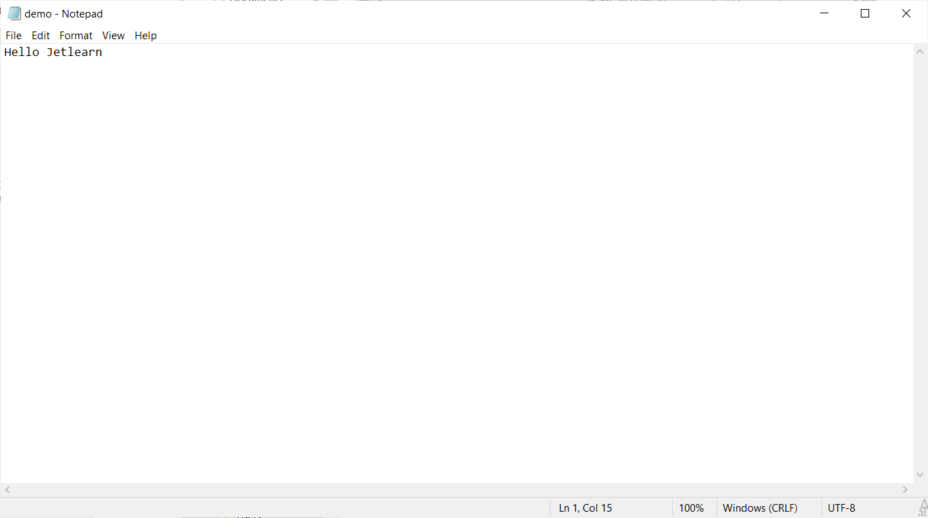

Lets Connect Remote and Local repository:

Now Lets link the Git to GitHub Account:

Make sure you have created a Github account first.

Now Lets get into GitHub and create a New repository.

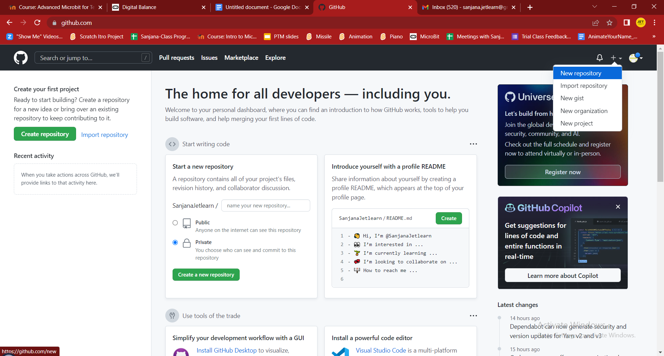

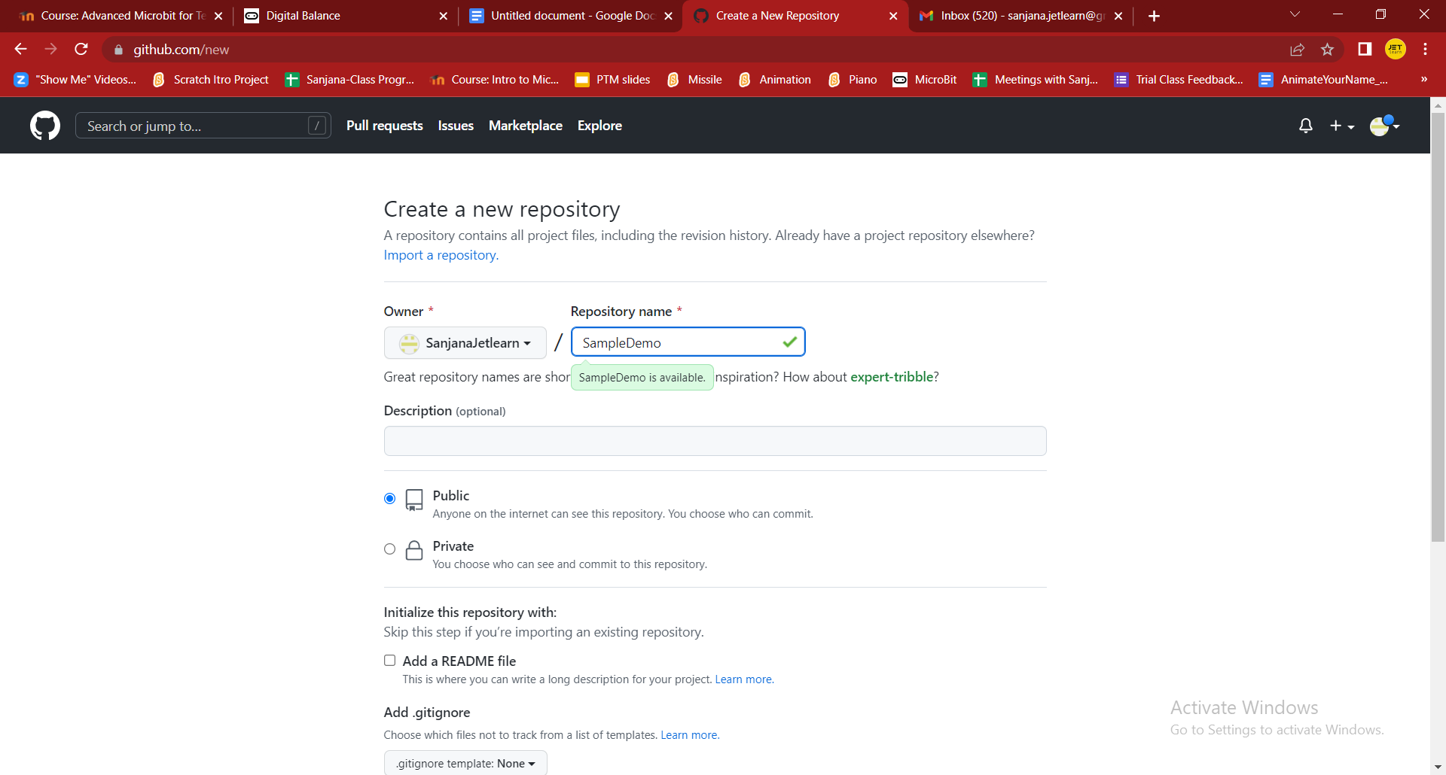

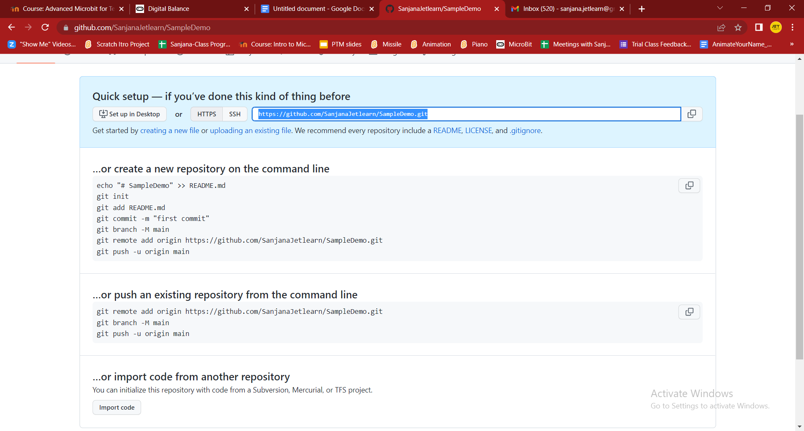

Now the repository is created which is remote.

Copy the link and go back to GitBAsh

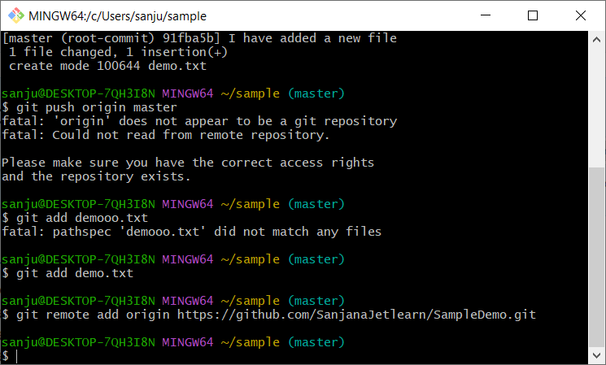

Get back to Bash and lets add Demo file which we created to remote repository:

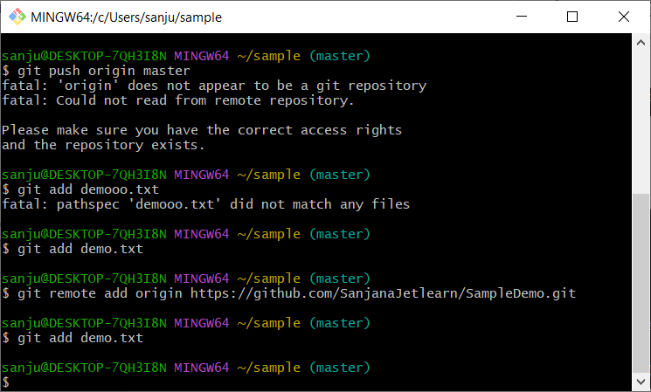

Lets commit the demo file using Git Bash

**$git commit -m “I have added a new File”**

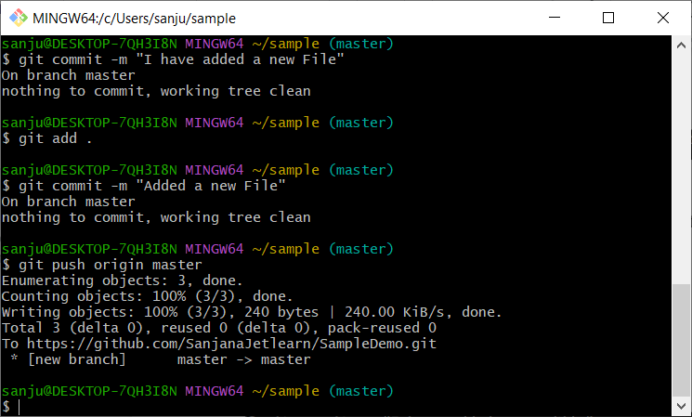

Lets push the file to remote repository:

**$git push origin master**



Now Lets check if the file is added on Remote repository(GitHub)

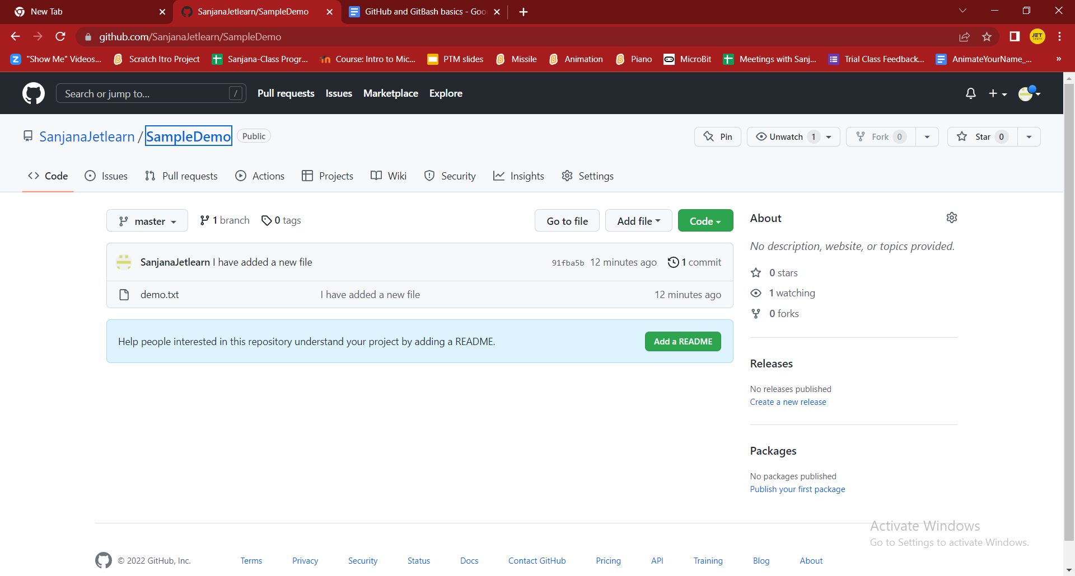

**Now Lets add the existing project on GitHub:**

Create a new repository on GitHub:

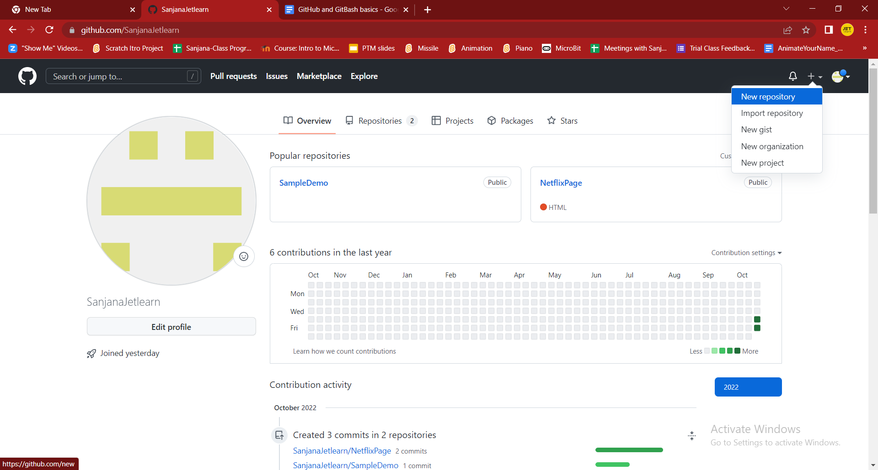

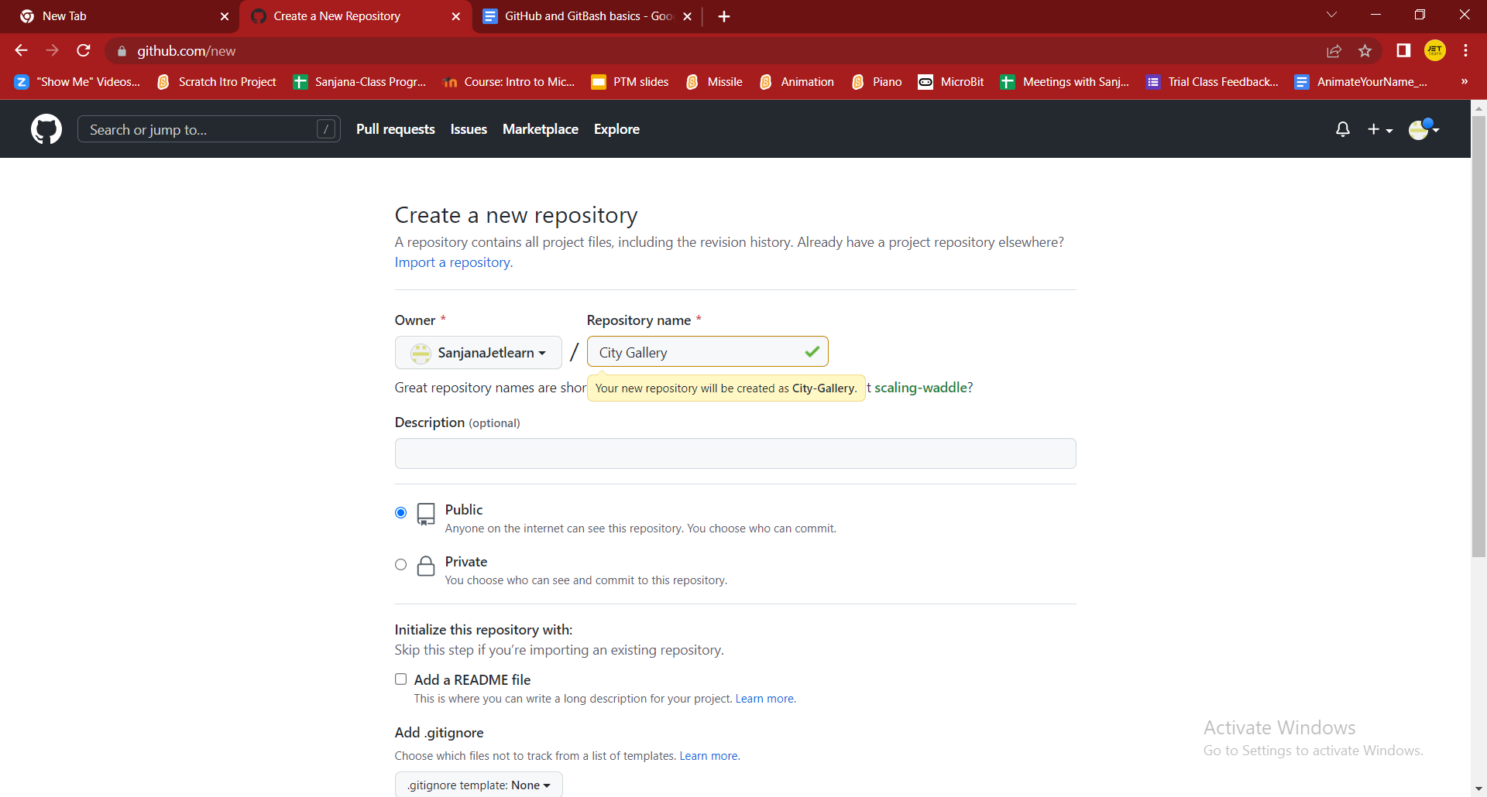

Copy the HTTPS link :

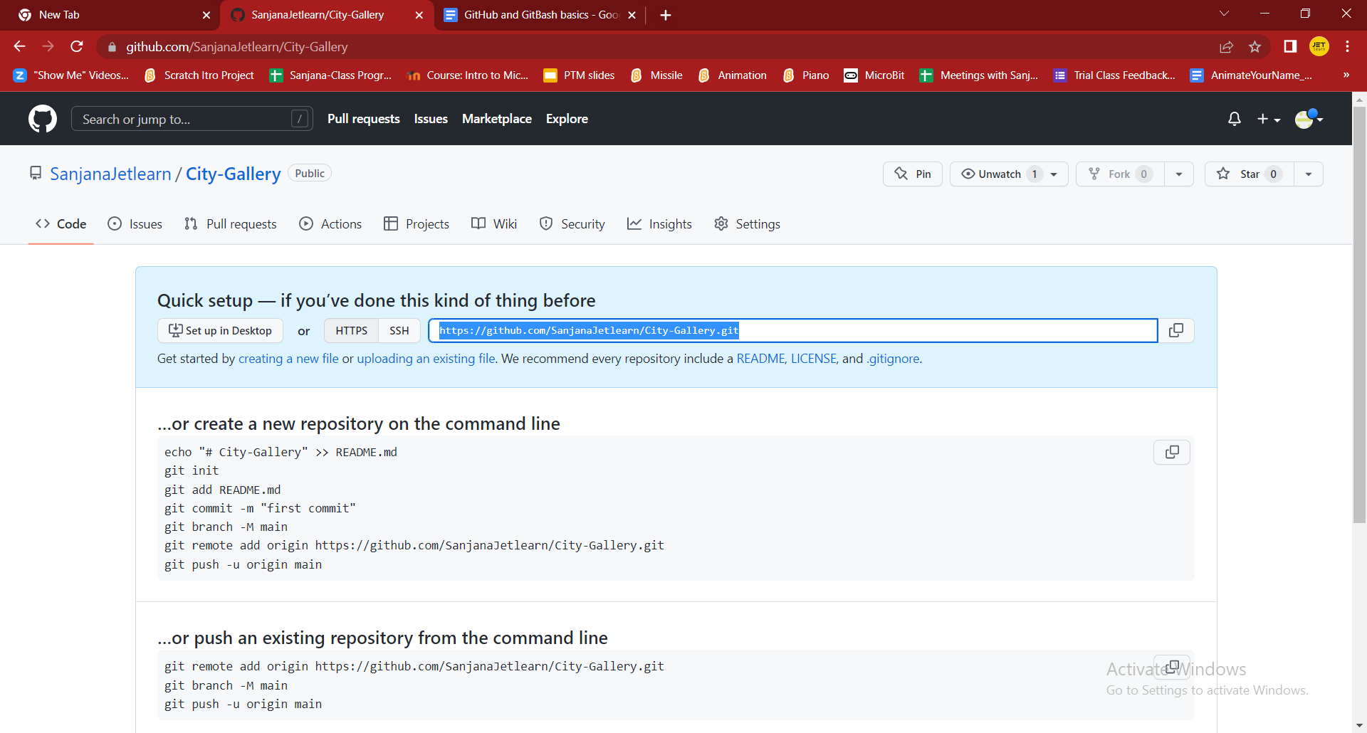

Now lets open the System Folder where we have our project folder

Right Click on the folder and select GitBash here:

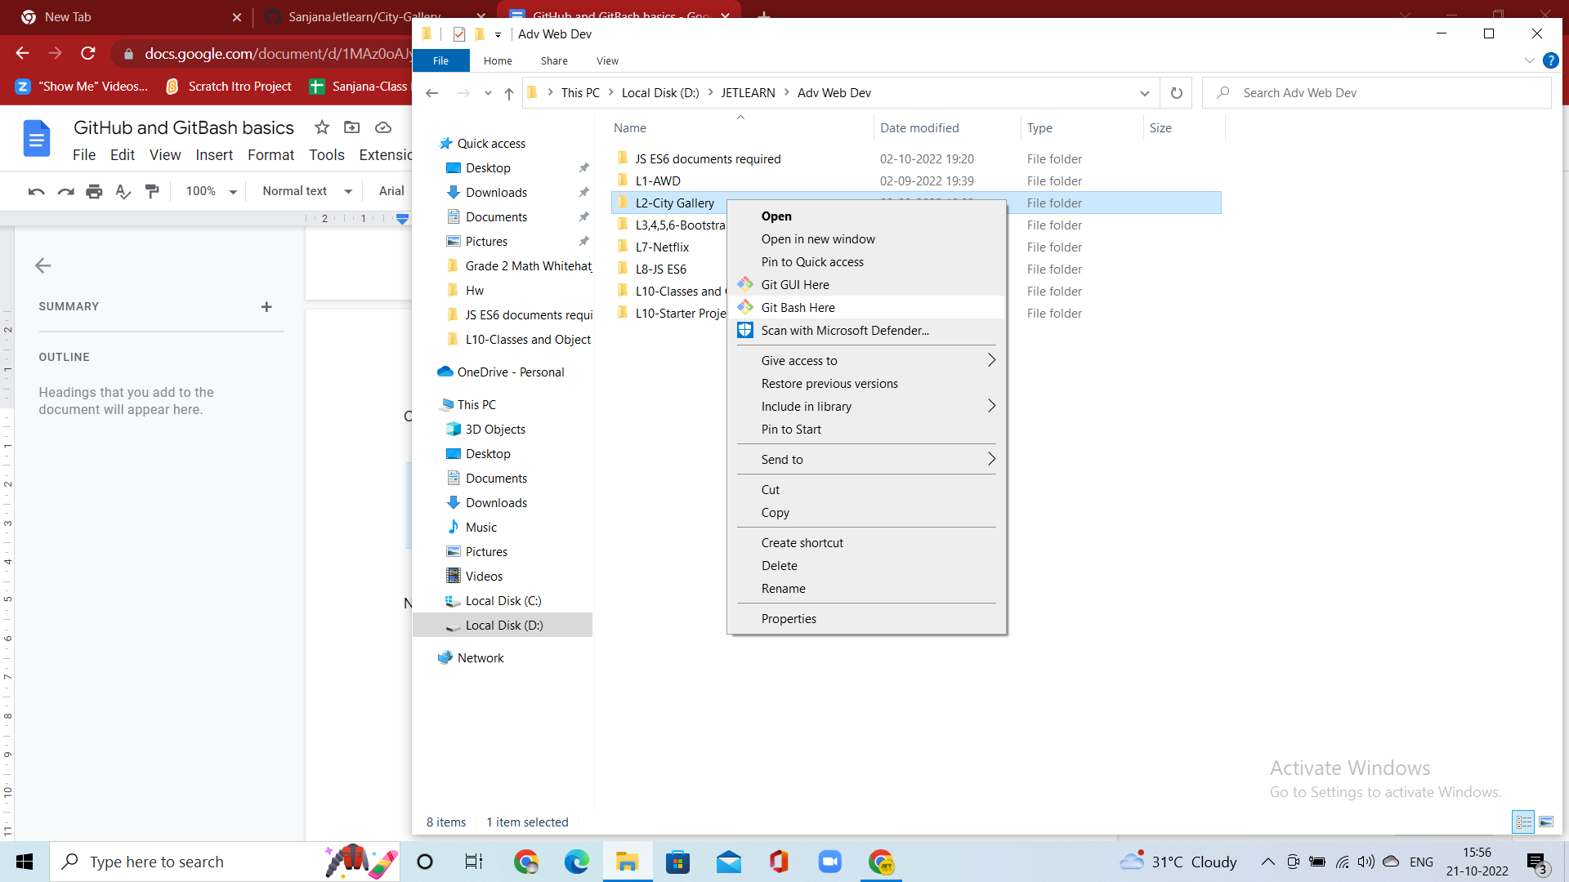

GitBash will be opened:

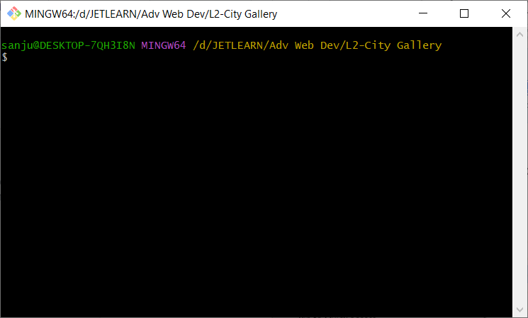

Lets now initialise the git

**$git init**

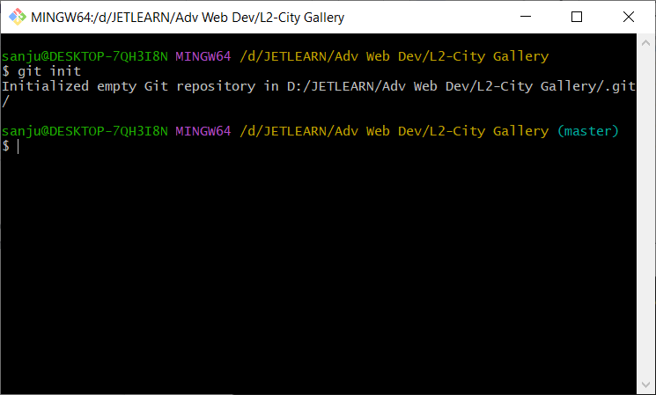

Now lets connect Local and Remote repository:

**$git remote add origin** [**https://github.com/SanjanaJetlearn/City-Gallery.git**](https://github.com/SanjanaJetlearn/City-Gallery.git)

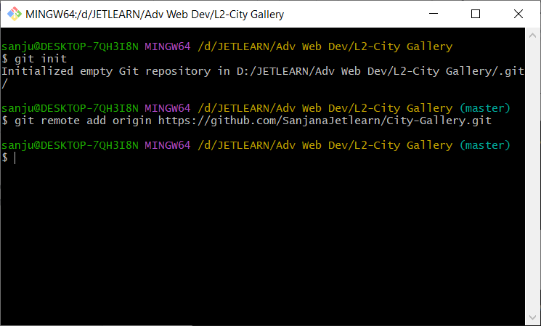

Make sure to paste the link of your repository from github.

Now lets add the files in the folder:

**$git add .**

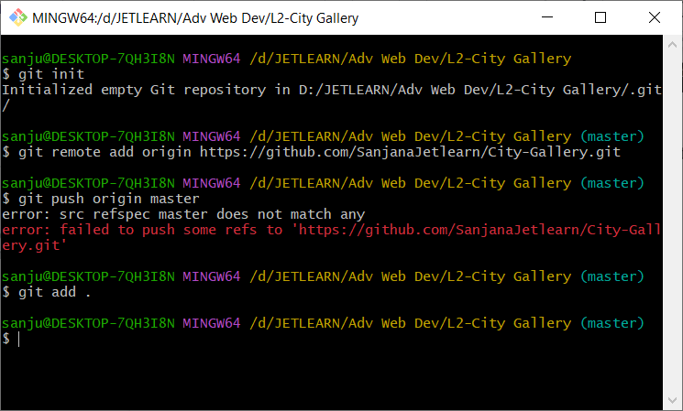

Lets commit the files:

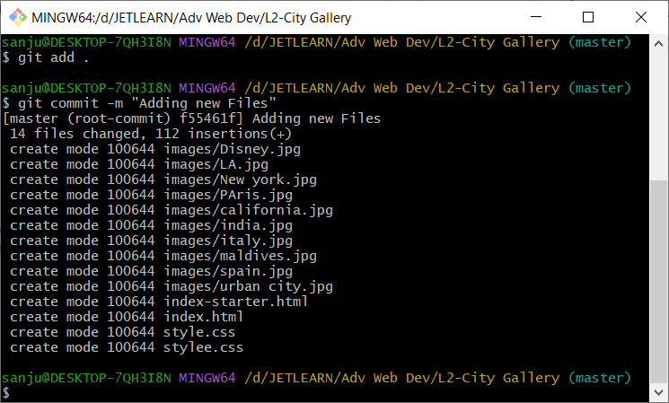

Now lets push the files to GitHub.

**$git push origin master**

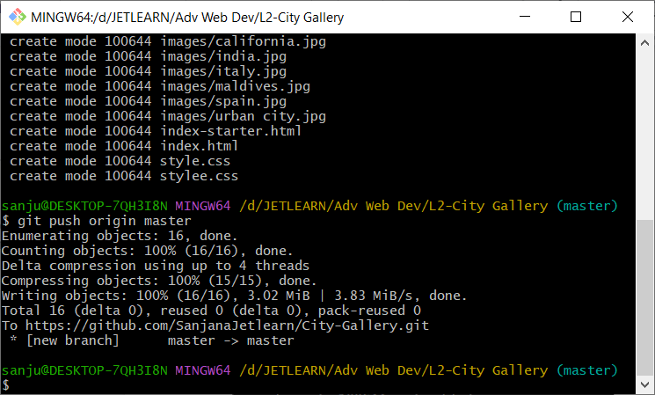

Now lets check the GitHub :

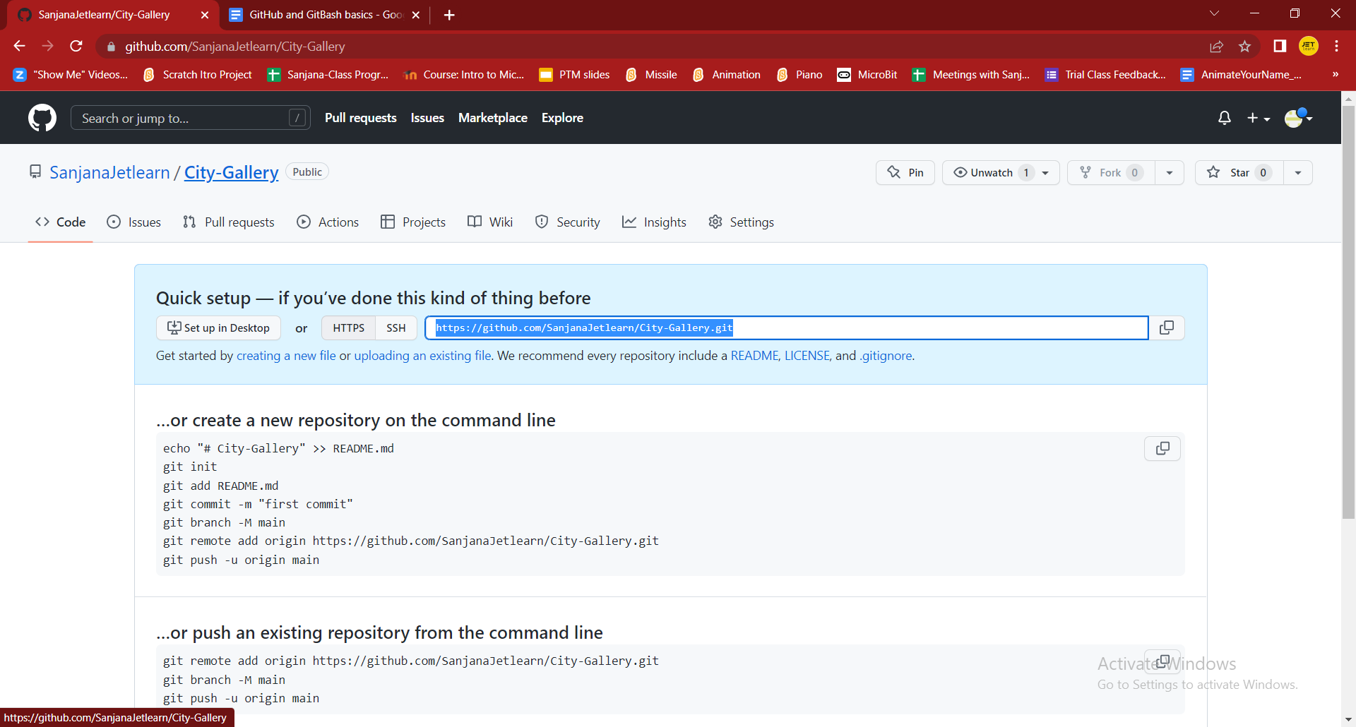

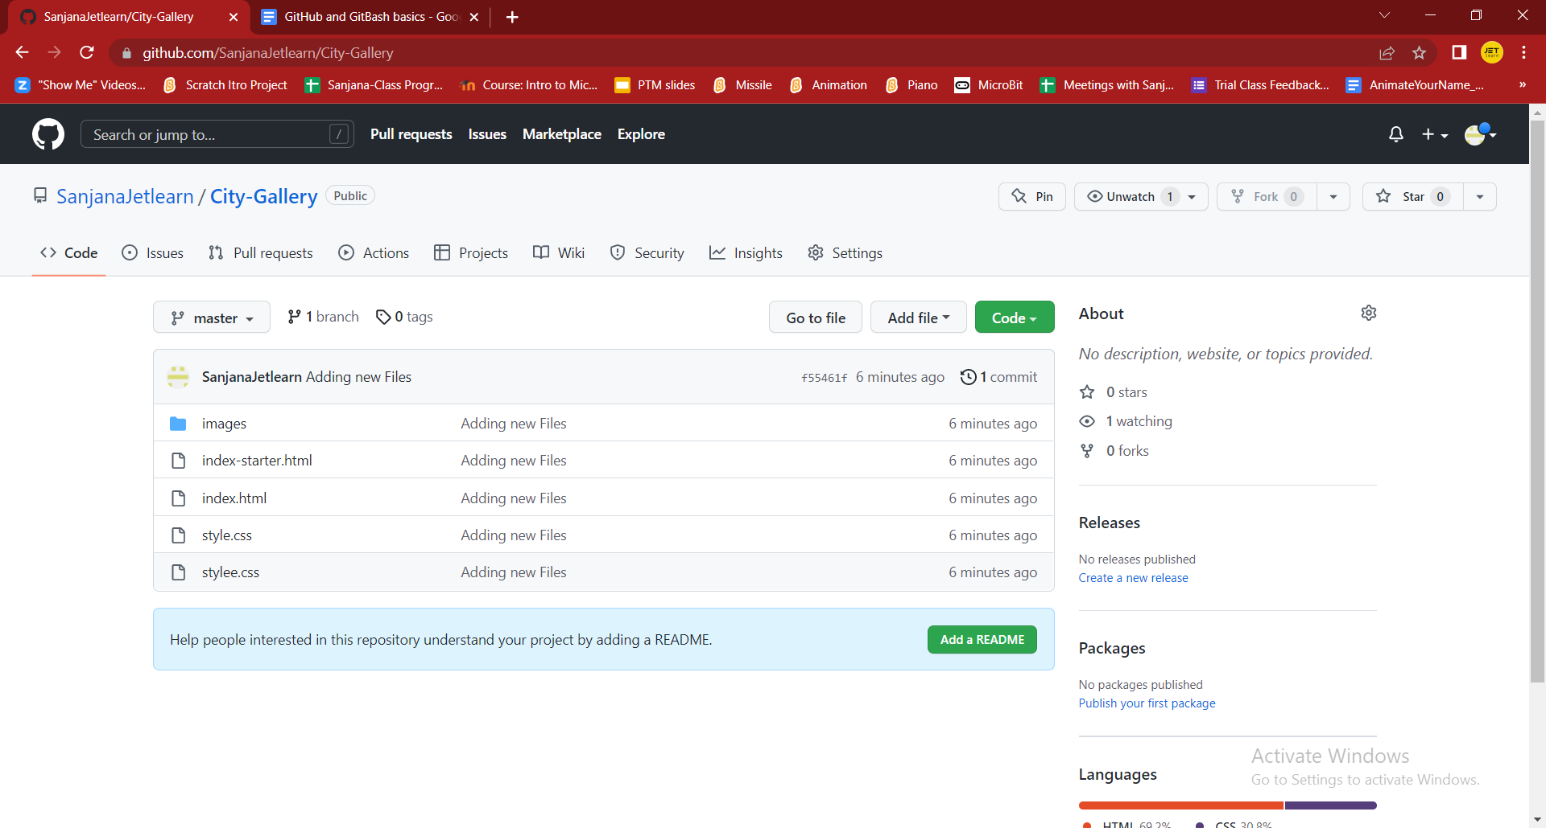

—-------------------------------------------------------

Profile Sharing :<https://github.com/SanjanaJetlearn>

—------------------------------------------------------------

**HOSTING WEBSITE**

Note: We can only host static websites.

From GitHub-> Click on the Repository that you wish to host:

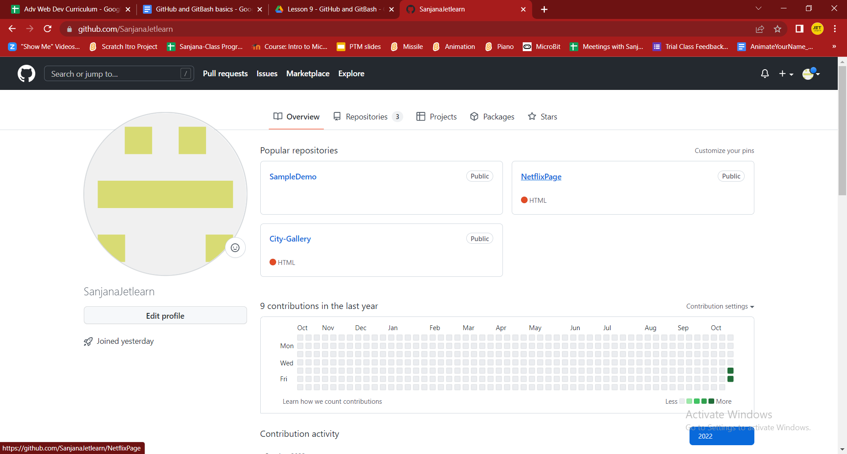

Click on Settings and Goto Pages Section from Left Side:

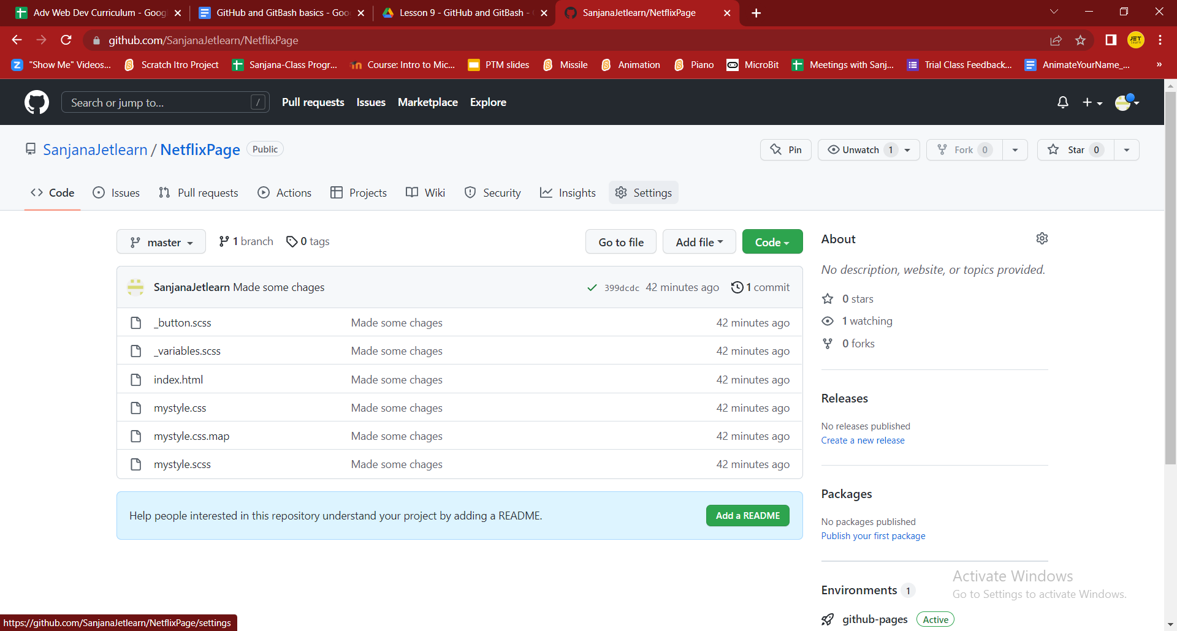

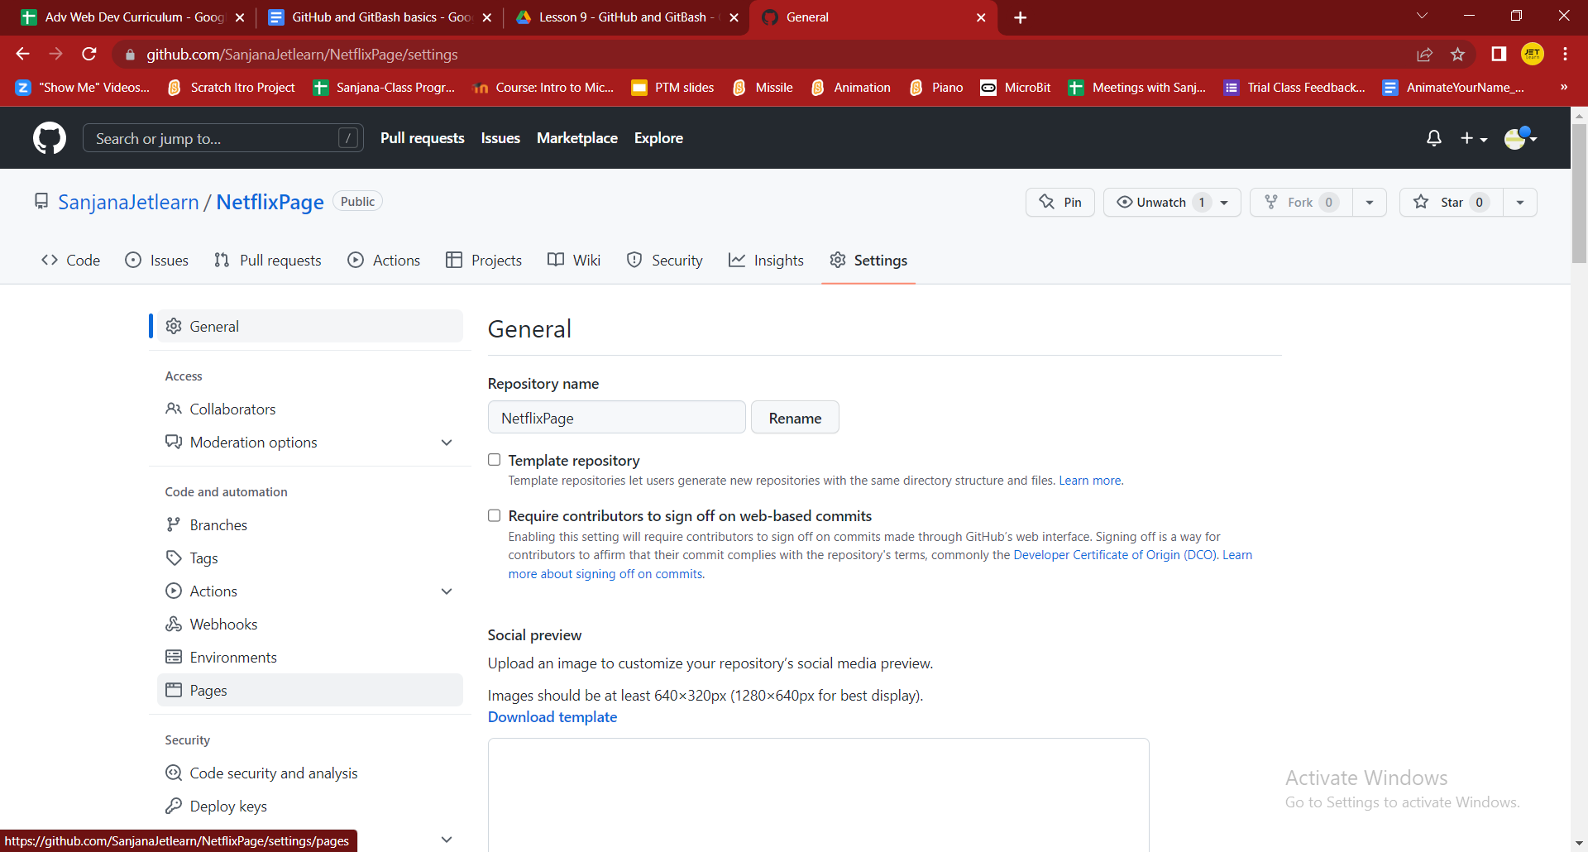

Select the branch as Main or Master:

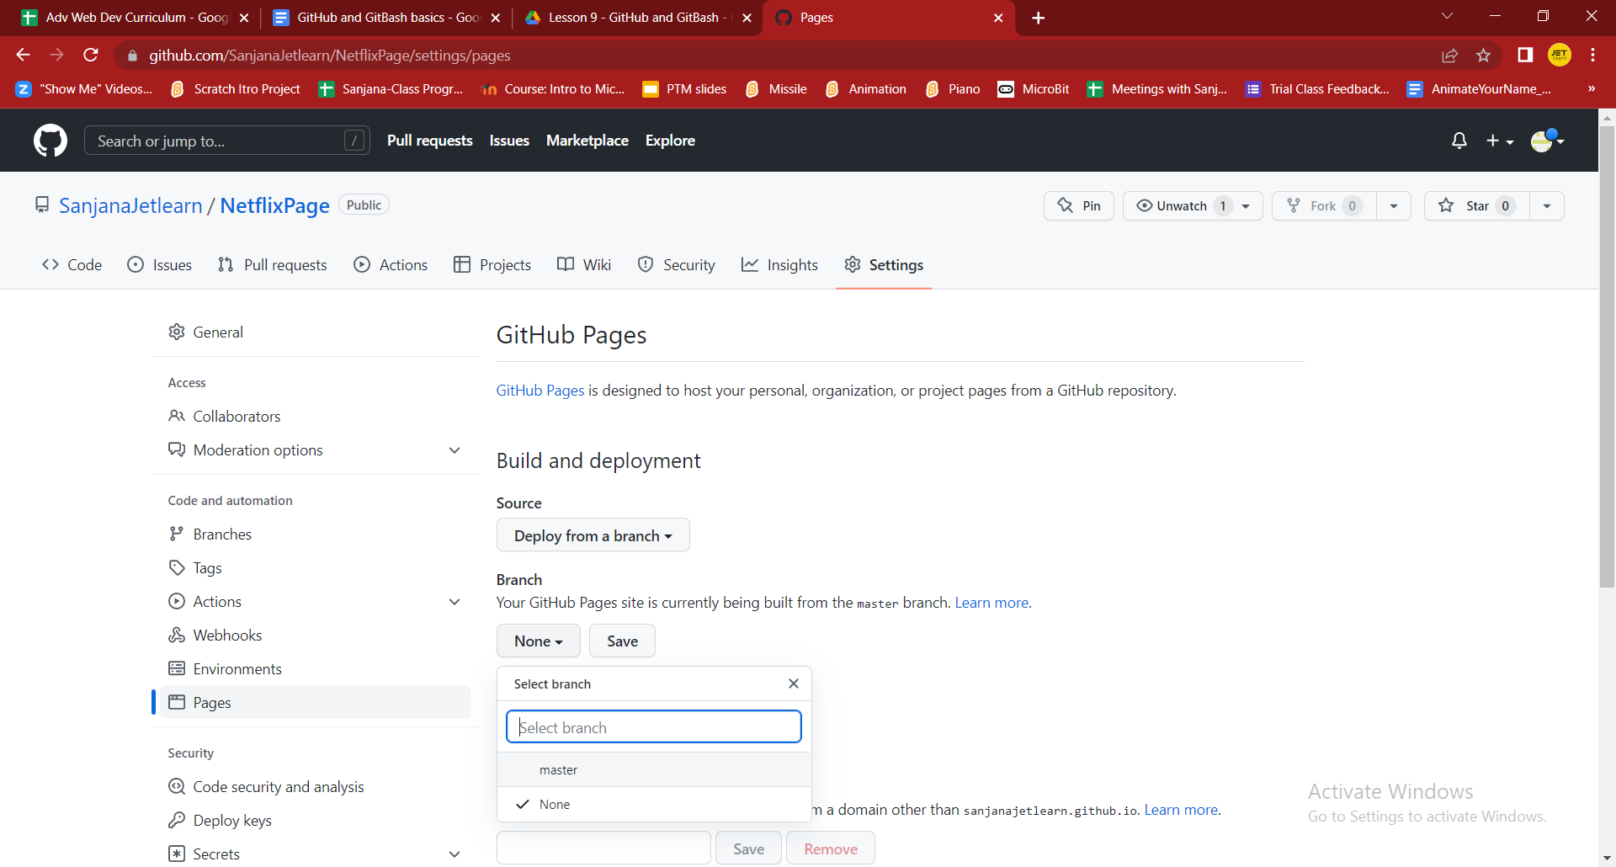

And Click Save.

After few minutes, Reload the screen. You should be able to see the visit link of your webpage:

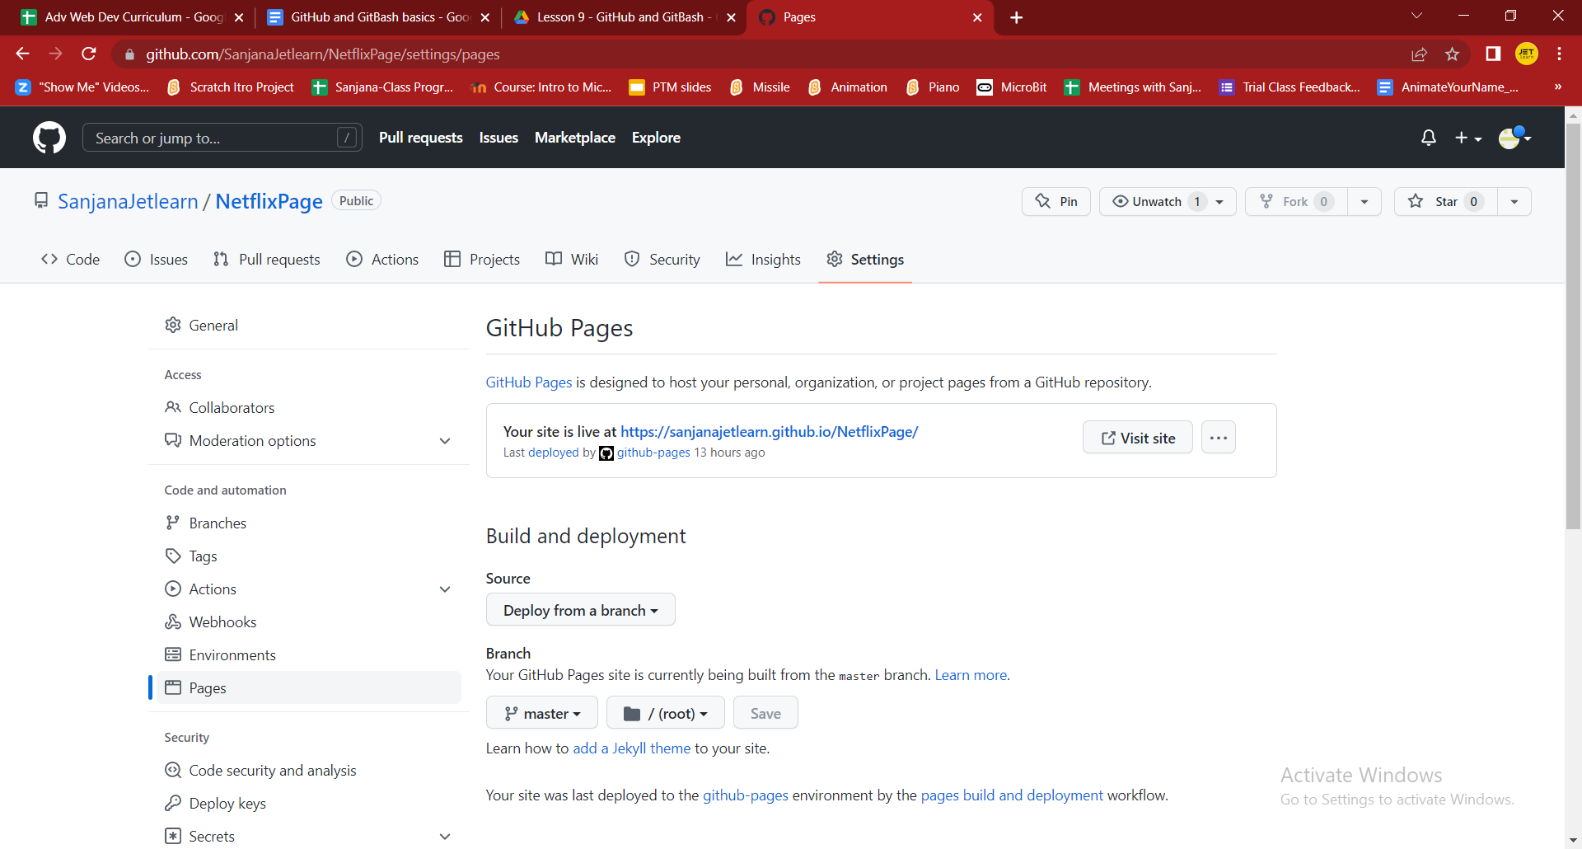

Click on the link to see the webpage.



Now you can copy the link and send the links to you family and friends :

<https://sanjanajetlearn.github.io/NetflixPage/>